This process is followed by the Payroll Officer managing the casual payroll and should be completed once the casual payroll deadline has passed, so that departments have had the opportunity to resolve any unapproved timesheets and/or add claims on behalf of workers.

This process will transfer the hours to CorePay (creating CorePay timesheets) and progress the CoreTime period to the next month.

Before creating the timesheets, it is possible to review errors by retrieving the hours in test mode, either for individual work groups or all work groups.

Part 1 - Test mode – Review errors/controls

Navigate to: CoreTime > Period End > Generate Timesheets

- Select ‘University of Oxford’ in the Company field.

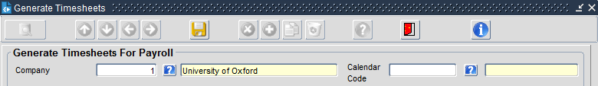

- Select Calendar Code ‘A’ in the Calendar Code field, this should populate the name of the calendar ‘New Monthly’.

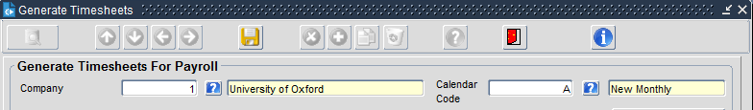

- Leave the Mode field set to the default ‘Test’. This will allow you review any errors before you create the Timesheets.

The Period field should display the current month as default.

- you can either view individual workgroups, groups of work groups, or select the entire lis.t

Work Group From field - Click on the ‘?’ to display the list of workgroups select the first of the work groups you wish to view and click ‘OK’

Work Group To field - Click on the ‘?’ to display the list of workgroups, select the last of the work groups you wish to view and click ‘OK’

Note: You may need to use the scroll bar to select the last Work Group on the list (images for example only, the Work Groups displayed will be different)

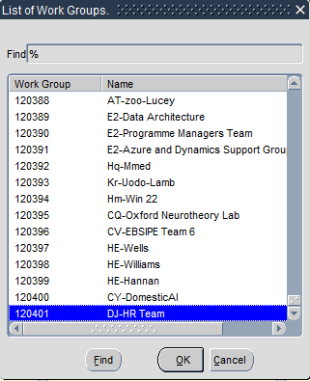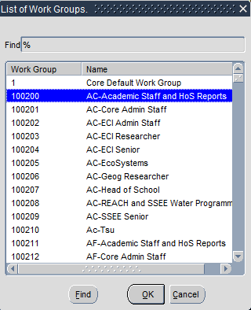

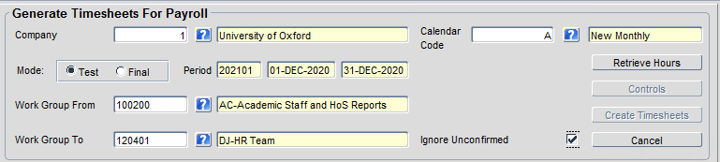
- Select the Ignore Unconfirmed checkbox and then click on the ‘Retrieve Hours’ button.

- The Pay Group Processing window will open, providing a summary of any warnings by Pay Group. Click on the ‘Yes’ button.

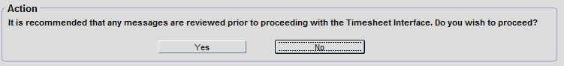

- The system will present a list of Errors/Warnings.

Payroll do not need to investigate individual errors, but a large number of errors may indicate that a department has not yet completed the sign-off process.

 | Note: When Departmental HR Administrators complete the sign-off process, they will also sign off absence codes. These codes do not form part of the ‘Generate Timesheets’ process, as none of the absence codes are pay-affecting in the University of Oxford configuration, but there is no way to remove them from the Errors/Warnings list

(Access Group unable to provide a definitive list of all errors, this is an explanation of the errors encountered during testing)

Type 1: Warning - Unapproved Codes
Hours that have been submitted but not approved (e.g. by a Manager)
These unapproved hours should have been identified by an HR Administrator and approved before the deadline. They will be paid in a future period once they have been approved (and signed off if required).

Type 2: Warning - Unconfirmed Hours
Hours that have been submitted and approved but not signed off by an HR Administrator
Hours that are approved by a manager do not need sign off, this error message relates to hours entered by an HR Administrator

Type 3: Warning – Unconfirmed tft/hols for non-payable Work Group
Hours that have been submitted and approved but not signed off in back-office
Hours recorded against absence codes (out of scope for timesheets) which have not been signed off.

Type 4: Warning - Unconfirmed Historical Hours
Hours which relate to a previous period that have been submitted and approved but not yet signed off by an HR Administrator
Hours that are approved by a manager do not need sign off, this error message relates to hours entered by an HR Administrator.

Type 5: Warning - Unconfirmed Outstanding Historical Hours
Hours which relate to a previous period that were unapproved when the period ended and have rolled forward into the current period.
These unapproved hours should have been identified by an HR Administrator and approved before the current period deadline. They will be paid in a future period once they have been approved (and signed off if required).

- Click on the Controls button

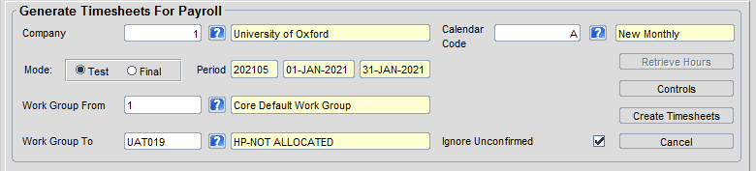

The Controls Totals window will open, displaying the hours that will be passed to CorePay.

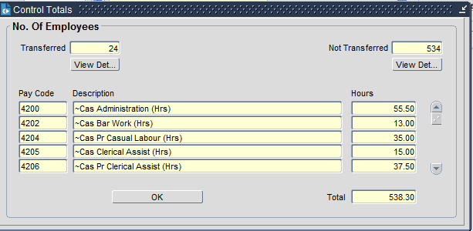
Total Hours across all workers/pay codes
Breakdown of hours by pay code
Headcount of workers with hours being transferred to CorePay

 | Note: You should not Create Timesheets in test mode, as this will pass the timesheets to CorePay, but will not progress the CoreTime period. Test mode should only be used to review errors.

Part 2 – Create Timesheets (Final Mode)
- Select ‘University of Oxford’ in the Company field.



- Select Calendar Code ‘A’ in the Calendar Code field, this should populate the name of the calendar ‘New Monthly’.



The Period field should display the current month as default.

- Change the Mode field set to ‘Final’.

Note: In Final mode you cannot select Work groups, the selection defaults to all work groups.

- Select the Ignore Unconfirmed checkbox and then click on the ‘Retrieve Hours’ button. 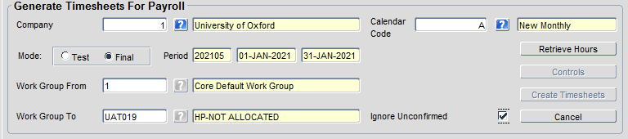

- The Pay Group Processing window will open, providing a summary of any warnings by Pay Group. Click on the ‘Yes’ button.



- Click on the Controls button



The Controls Totals window will open, displaying the hours that will be passed to CorePay.


Total Hours across all workers/pay codes
Breakdown of hours by pay code
Headcount of workers with hours being transferred to CorePay

- Once you have reviewed/notes the Controls Totals, click on the Create Timesheets Button



